Director: Lee Cook |  |  | (516) 481-0943
Yankees | Manager: | Charlie Scott | (631) 835-9172
 | Coach: | Jason Cohen | (516) 993-6673
 | Coach: | Dan Cohen | (516) 404-5667
 | Coach: | Ashley Kummer | (850) 530-5276
Dodgers | Manager: | Tony Lipovec | (516) 414-4800
 | Coach: | Mike Beiner | (718) 423-1442
Cyclones | Manager: | Frank Alfano | (516) 293-5021
 | Coach: | Kevin Kamper | (516) 538-7096
Ducks | Manager: | Kevin McShane | (516) 208-5262
 | Coach: | Seth Alexander | (516) 586-6812
Mets | Manager: | Russell Merendino | (516) 390-5692
 | Coach: | Harvey Pollack | (516) 867-0516
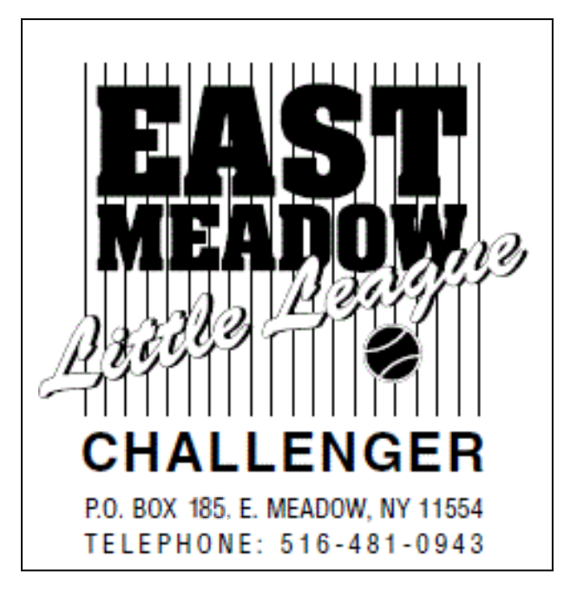

2022 CHALLENGER FALL SCHEDULE - REVISED 8/26/2022
DAY | DATE | TIME | FIELD
SUN | Sept 11 | 9:00 am | Cook, Gaglione, Grieco, South
SUN | Sept 18 | 9:00 am | Cook, Gaglione, Grieco, South
SUN | Sept 25 | 9:00 am | Cook, Gaglione- DUCKS & YANKEES
SUN | Sept 25 | 12:00 pm | JAMBOREE- BURNS PARK- Mets, Cyclones & Dodgers__
SUN | Oct. 2 | 9:00 am | Cook, Gaglione, Grieco, South vs. Plainview & Braves
SUN | Oct. 2 | 2:00 pm | METS AWAY @ CENTRAL SUFFOLK
SUN | Oct. 9 | 9:00 am | Cook, Gaglione, Grieco, South vs. Chiefs
SUN | Oct. 9 | 10:00 am | YANKEES AWAY AT PLAINVIEW
SUN | Oct. 16 | 9:00 am | Cook, Gaglione, Grieco, South vs. Central Suffolk
SUN | Oct. 23 | 9:00 am | Cook, Gaglione, Grieco, South -Yankees, Ducks & Dodgers
SUN | Oct. 23 | 3:00 pm | METS & CYCLONES AWAY @ MASSAPEQUA
SUN | Oct. 30 | 9:00 am | Cook, Gaglione, Grieco, South

- Be at the field at the scheduled time so the game can start on time
- Please check our website frequently for schedule revisions: www.embsa.net
- AOL USERS make sure to reload the page while holding down control key for latest updates
- In most cases games will not be cancelled due to inclement weather until one hour prior to schedule starting time.
- Leagues website can be found at embsa.net, challenger info is at embsa.net/challenger

